1. Open PowerShell on your Windows laptop

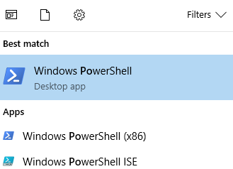

1. Navigate to the folder containing the script to change the password using the following command: “cd /Users/mkayeshort/repos/volunteer-points-log/tools”

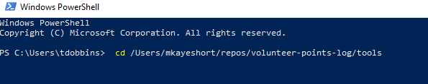

1. Run the script using the new password with the following command: “./update-admin-password.ps1 NEWPASSWORD”



1. If the script ran successfully it will display a “password changed” message.

